DIS-US-OK- Spiro Mounds Spud from La Fore County, Oklahoma

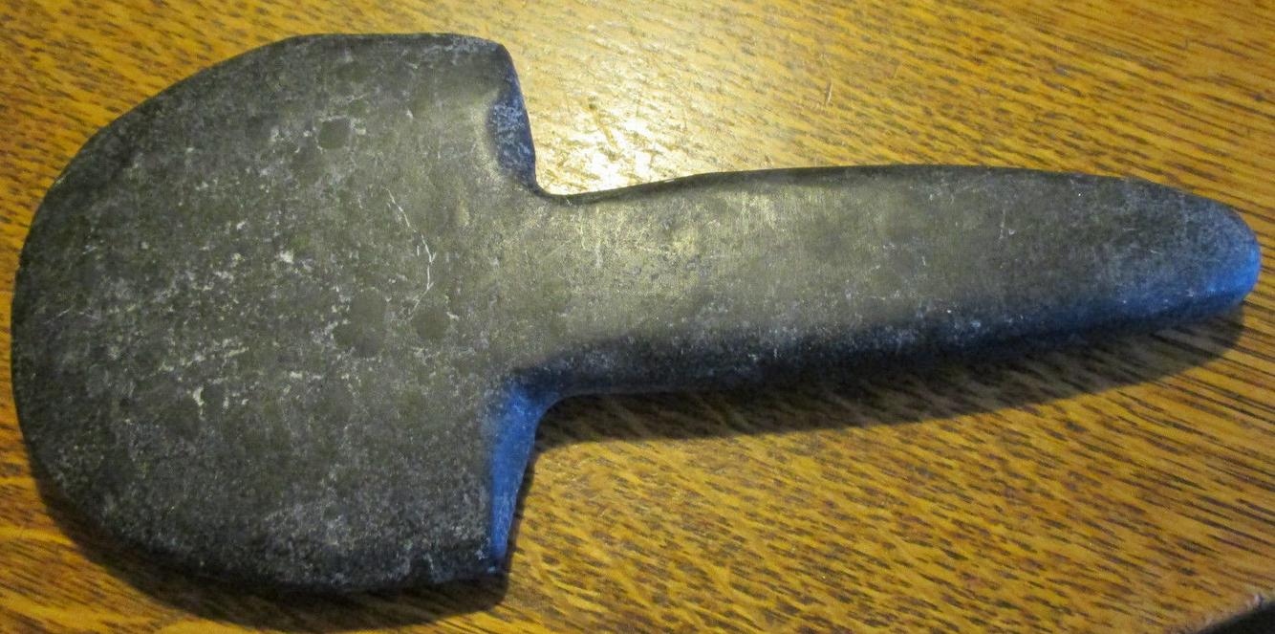

# Ceremonial spatulate ritual axe, 8 1/2" long, similar to that from Spiro Mounds, La Fore County, Oklahoma.

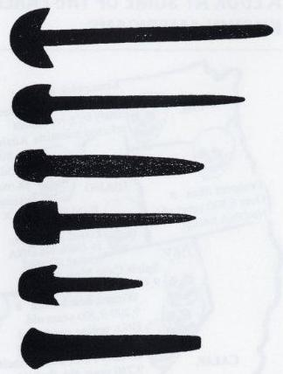

**Silhouettes of some of the more famous "spuds" or spatulate ritual axes from top down: spud from Spiro Mound in La Flore County, Oklahoma; The "Grove Spud," from St. Clair County, Illinois, the Sutter spud from the American Bottoms in Illinois; the Spiro Mounds spud from La Fore County, Oklahoma; the Soucy Cemetery Site spud, from St. Clair County, Illinois; and the Thibault Spud from Pulaski County, Arkansas**.